GDD 0.1.

Authors: Valdis, Atis, Mija, Kriš, Gvido, Viktors, Artūrs, Ieva, Saša, Samanta, Edgars, Anna, Paula

Roles.

  - Responsibilities (can and may change)
Person trying to organize stuff – Valdis.
Will try to organize overall project work. All the questions regarding the overall project workflow can be asked to the person trying to organize stuff.
Visual Lead – Mija.
Will try to keep a coherent art style accross the project. All the questions regarding art style dirrection can be asked to the visual lead.
Audio Lead – Saša.
Will try to keep a coherent audio style accross the project.All the questions regarding audio style dirrection can be asked to the audio lead.
Technical Lead – Viktors.
Will try to keep a coherent programming style accross the project.All the questions regarding technical side of the project can be asked to the technical lead.
  - Everyones abilities and preferences. (feel free to update your own)
Valdis – Technical, VR. Atis – Visual.
Mija – Visual. Kriš – Technical.
Gvido – Visual, Technical, Audio. Viktors – Technical.
Artūrs – Visual, Technical, Audio. Ieva – Visual.
Saša – Visual, Technical, Audio. Samanta – Visual.
Edgars – Technical, 3D Models. Anna – Visual, UI, UX.
Paula – Visual.
Everyones currently assigned task can be viewed here - https://github.com/Opscury/VR-Grupa/projects/1

Game summary. (Work In Progress)

Genre – VR, Escape Room.
One night you are abducted from your bed by an alien spaceship. The game takes place inside an alien elevator, using whitch the player is able to switch floors that, in a way, act like rooms in any other escape room game.

  - Visual. (Work In Progress)
Style – Sci-Fi, Alien, Spaceship.
A moodboard is being prepared and will be put here once ready as reference.

  - Audio. (Work In Progress)
Style – Simplistic.
An ambient background music is being prepared and it will be possible to use it as a refference for other audio efects.

  - Technical. (Work In Progress)
Locomotion – None, the main way the player will move around the game world will be by using the elevator. So everything that’s being made, should be kept within arms reach.
Object Grabbing – This is the main VR mechanic, through whitch the player will interract with the game.

Puzzles. (Work In Progress)

Listed below are the puzzles that will be present in the game and the way they will work. Once everything needed for a puzzle to be implemented is made, someone will implement it.
  - Light Redirection
A shining light/laser will be present that the player will need to redirect using a mirror to a target position for a thing to happen.
  - Indiana Jones
A necesarry-to-retrieve object will be on top of a stand with a pressure plate. Once the object is removed, the plate will start to slowly sink in the object and will continue to do so untill the object or any other with same weight is placed back on top of it. If the plate sinks in low enough, a negative thing will happen.
  - Radio
The right frequency of the radio, that the player can change at any moment, in collaboration with other factors, will make a thing happen.
  - Alien Language
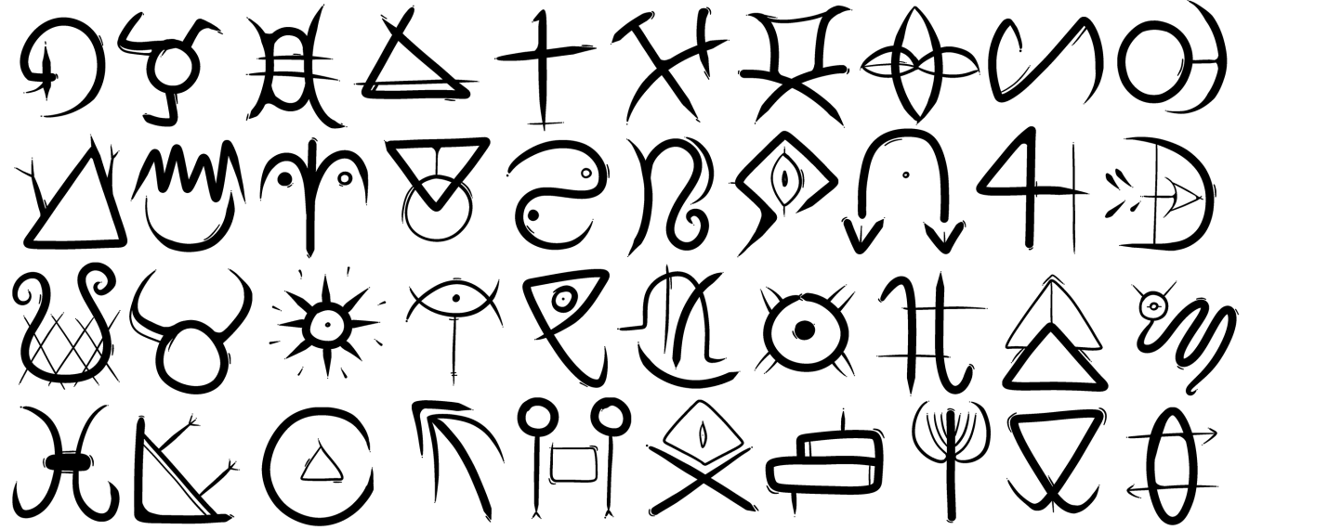
Figure 1 - Alien Language Symbols
A „book shelf” with alien „books” that have alien writing on them using symbols shown in Figure 1. Somewhere else in the room, there’s an incomplete sentence, that exists in complete form on one of the alien „books”. When the player finishes the incomplete sentence to be the same as in the book, a thing happens.

Project Dirrection (will be updated regularly)

The current objective we are working towards is the creation of the first elevator room with some basic puzzles that can introduce us to the game we are making. The Estimate is that this could be done by the end of the month. When that is done, a meeting will be held for the purpose of giving the oportunity for everyone to play-test the first floor.

Collaboration

For the storage and sharing of all the files relating to this project, we will use GitHub. In some cases other methods will be used, because GitHub Desktop is only available on 64 bit systems.
  - How To Upload A File (Without GitHub Desktop)
Open the github repository https://github.com/Opscury/VR-Grupa, then click the “Upload Files” button as shown in Figure 2.
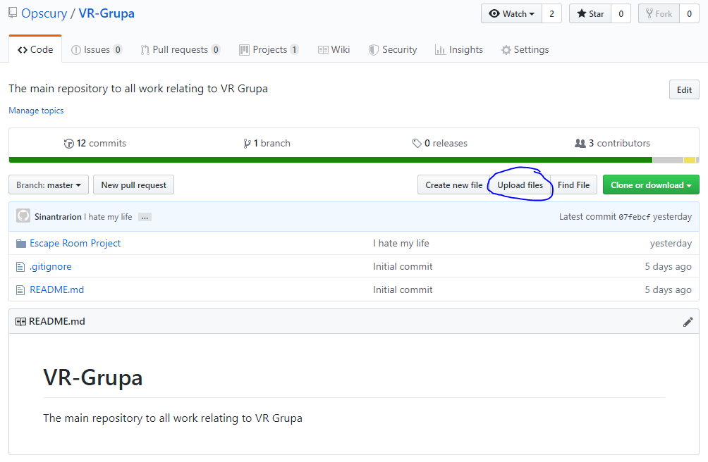
Figure 2 - GitHub Upload Files Button Location
Next drag and drop the files you wish to upload, add the title and if necesarry a description , then click „commit changes” and your files will be uploaded to the repository and become available to everyone else.
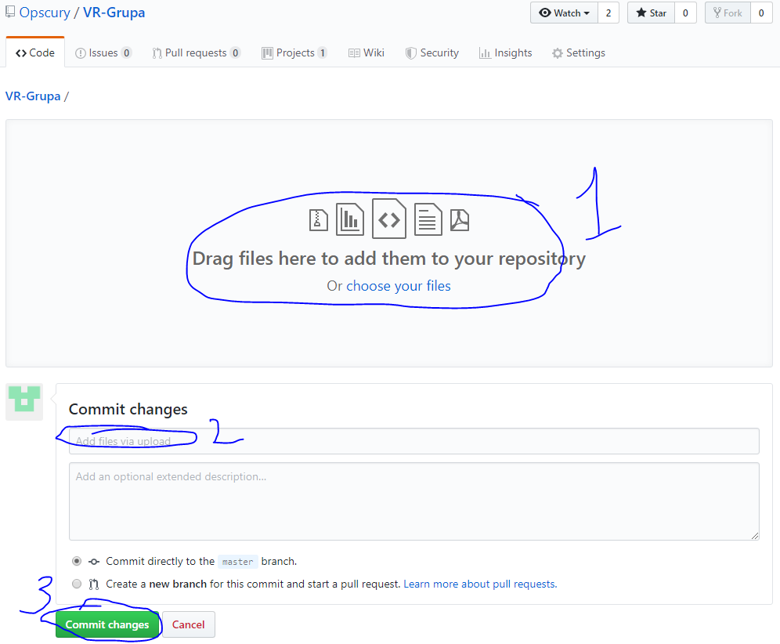
Figure 3 - GitHub Commit Window
  - How To Clone The Repository To Your PC
Download and install GitHub Desktop https://desktop.github.com/
Copy the clone link from https://github.com/Opscury/VR-Grupa as shown in Figure 4.
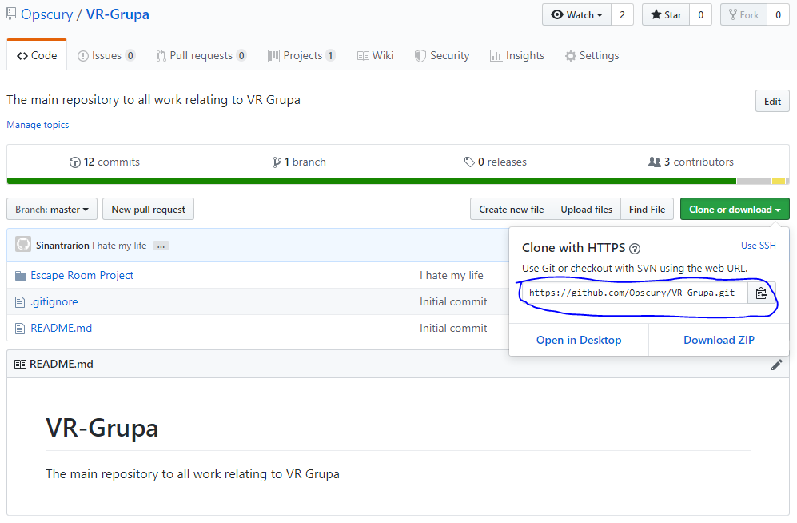
Figure 4 - GitHub clone link location
Paste the link in GitHub Desktop in the shown location in Figure 5 and click clone. After that the client will begin to download the repository to the selected location. Once done you have now successfully cloned the repository to your pc.
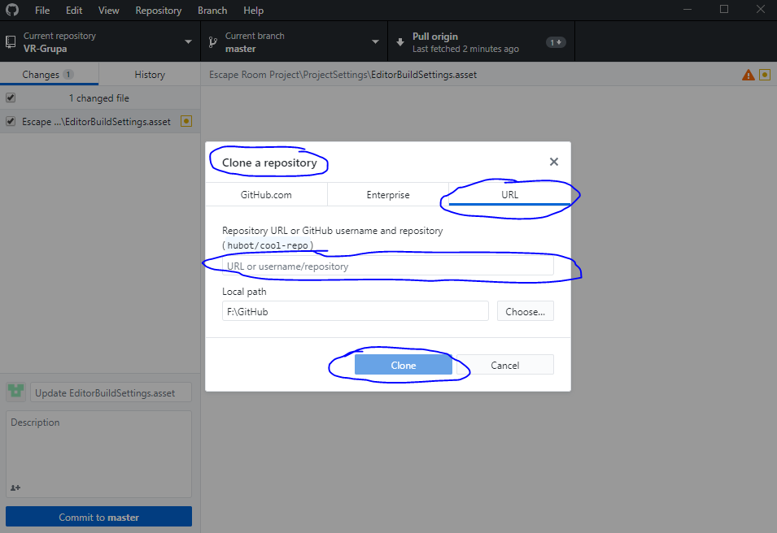
Figure 5 - GitHub Desktop Clone URL

  - How To Upload Changes To The Repository
Make any changes you wish to uplaod in the location where you cloned your repository to.
Open GitHub Desktop, add a title and description to your changes if needed as shown in Figure 6 and press „commit to master”
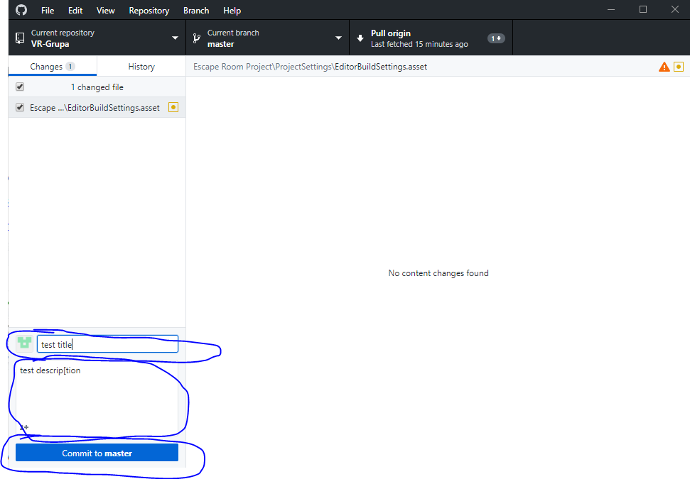
Figure 6 - GitHub Deskop commit
After commiting, your changes are saved, but are not yet uplaoded to the GitHub repository. To do that, click „Push Origin” button as shown in Figure 7. Now all the changes you made, are available to every other developer on this project.
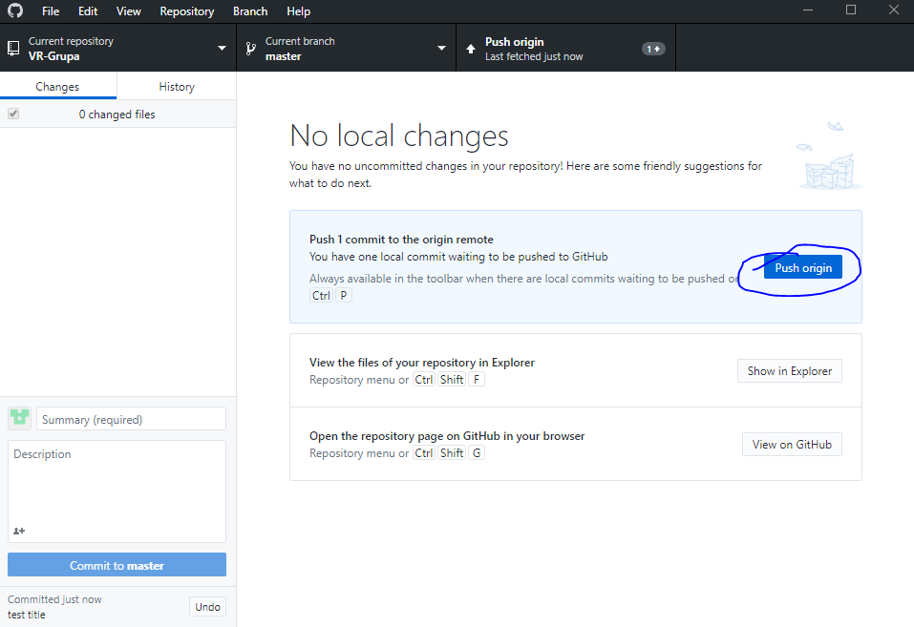
Figure 7 - GitHub Desktop push origin

  - How To Update Your Cloned Repository
To check if there are any updates to the repository that you should download, click the fetch origin button as shown in Figure 8.
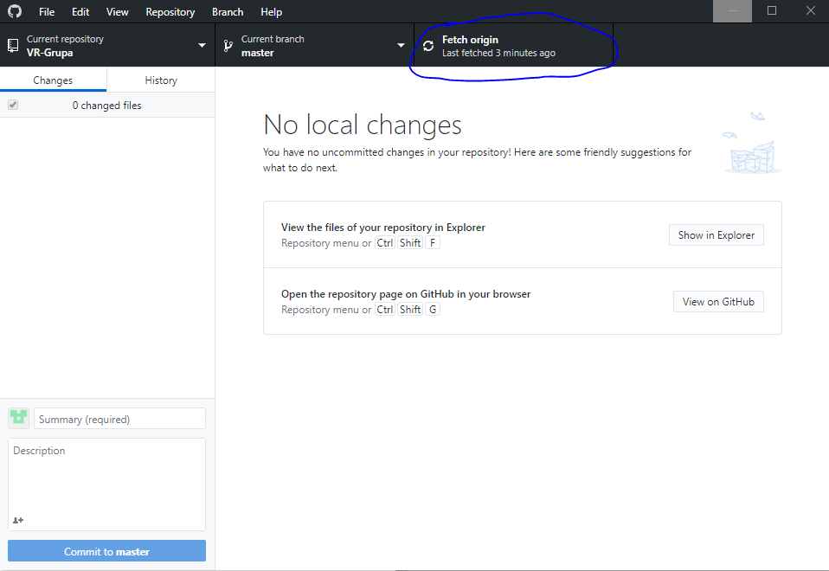
Figure 8 - GitHub Desktop fetch origin
If changes are detected, click the „pull origin” button as shown in Figure 9 and your local repository will be updated.
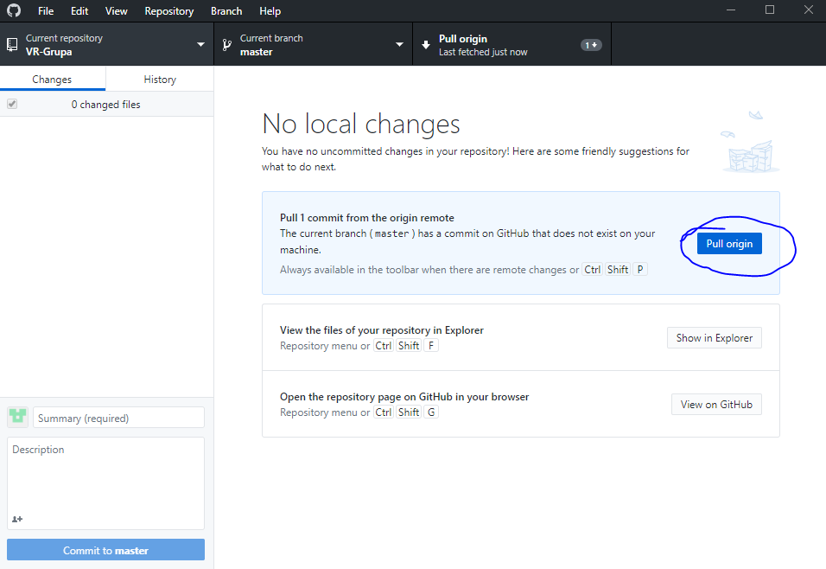
Figure 9 - GitHub Desktop pull origin

